Novel Ideas

——A vue project

Yi Xue

20086419

# Environment

OS: Windows 10

Node: v10.16.3

# Code repository

<https://github.com/Ella-Xue/Novel-Ideas-Frontend>

<https://github.com/Ella-Xue/NovelIdeas-api>

# Description of Functionality

# Client

<https://github.com/Ella-Xue/Novel-Ideas-Frontend>

[http://novelideas.surge.sh/](http://novelideas.surge.sh/#/)

<https://novelideas-frontend.firebaseapp.com/#/>

### Sign in

User can Sign in with username and password

Click the button Sign in

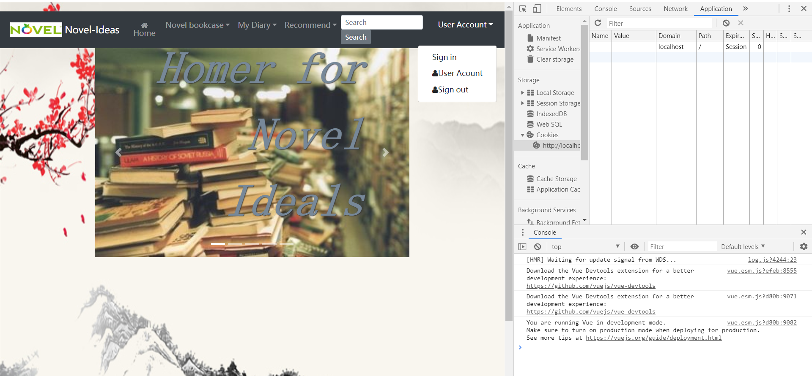

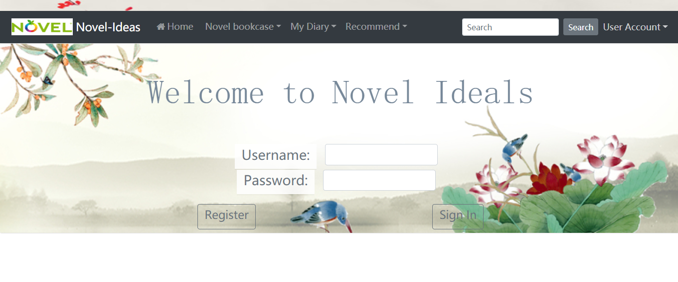

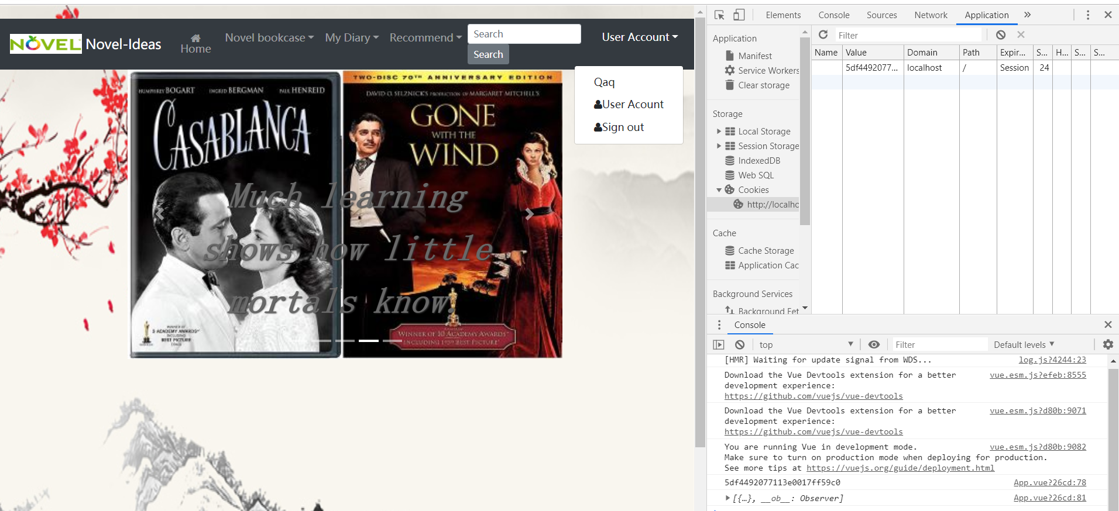

### Register

Click Register

Allow user to register

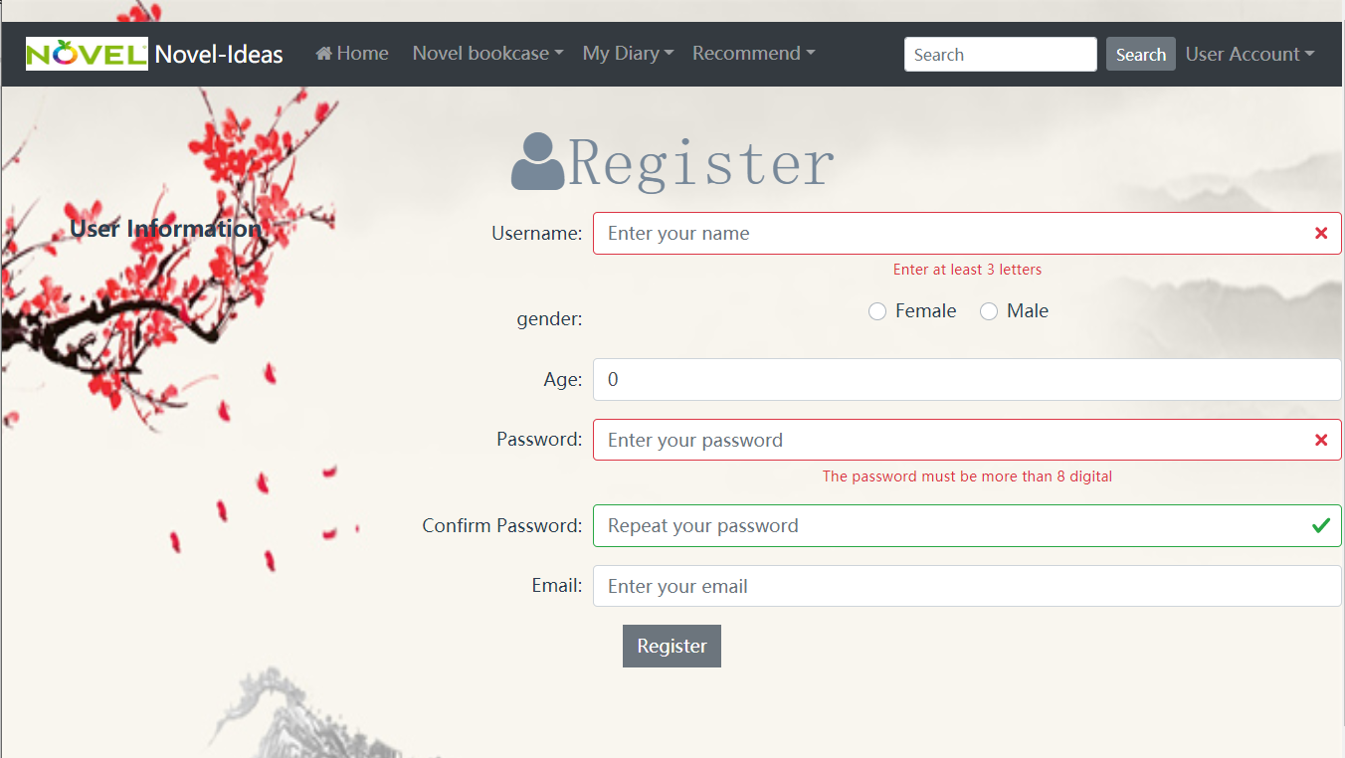

### Home page



### All novel list

All user to view the novel list

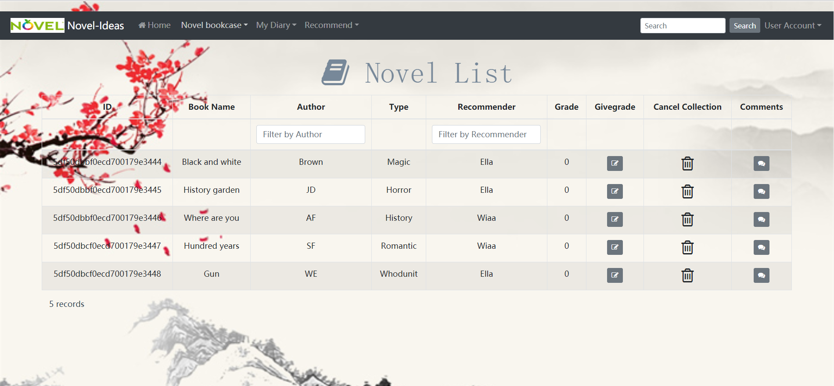

### Share novels

Allow user to share novels

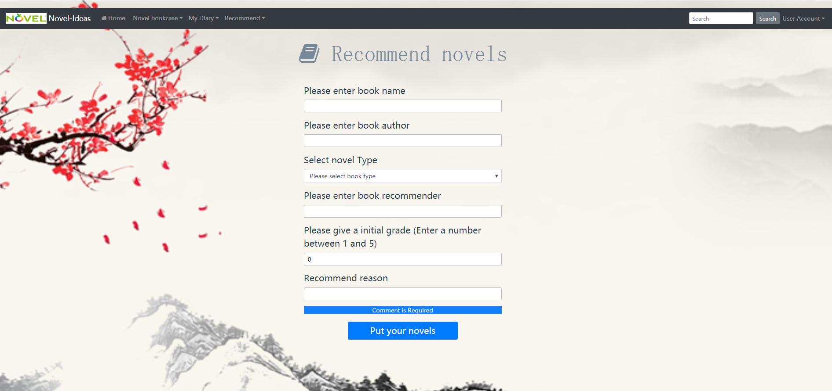

### Collect novels for themselves

All user to collect novels for them selves

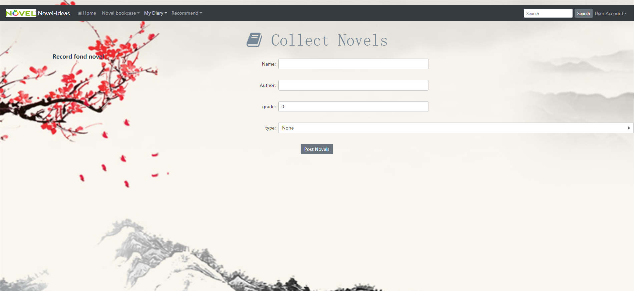

### All author list

Allow user to view all authors

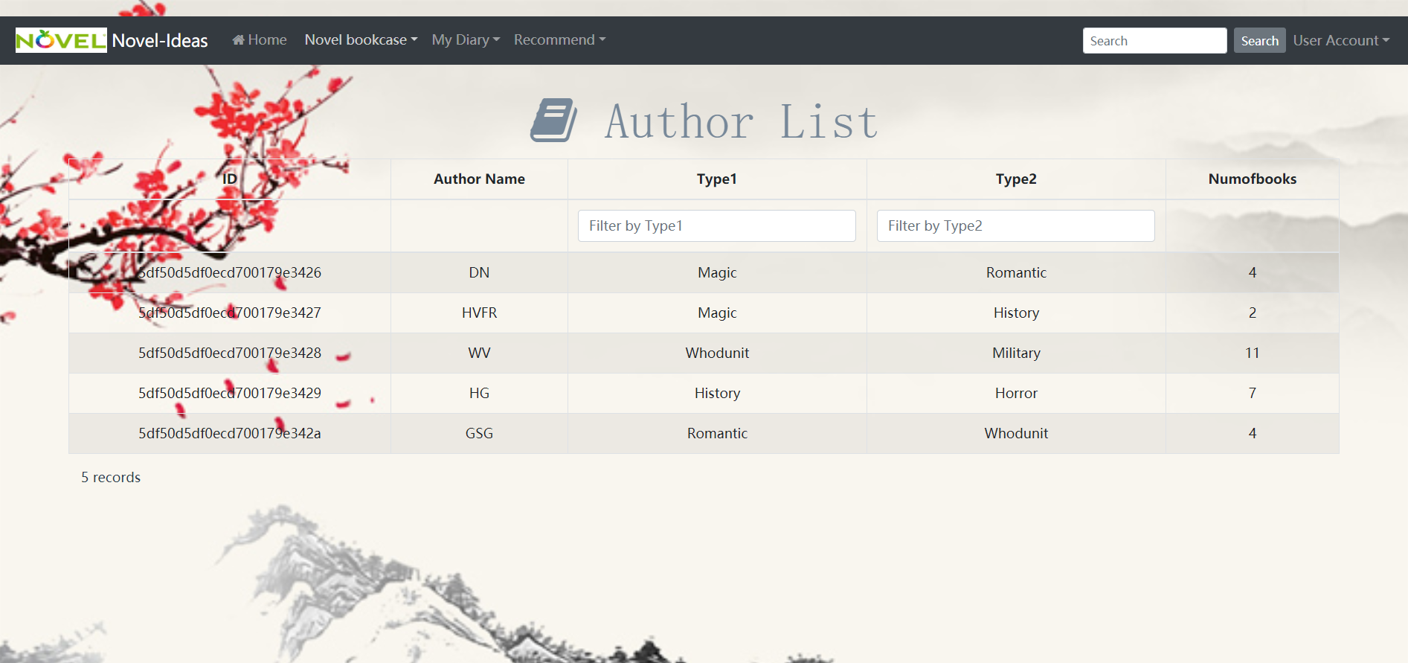

### Share authors

Allow user to share authors



### Collect authors for themselves

Allow user to collect author for themselves

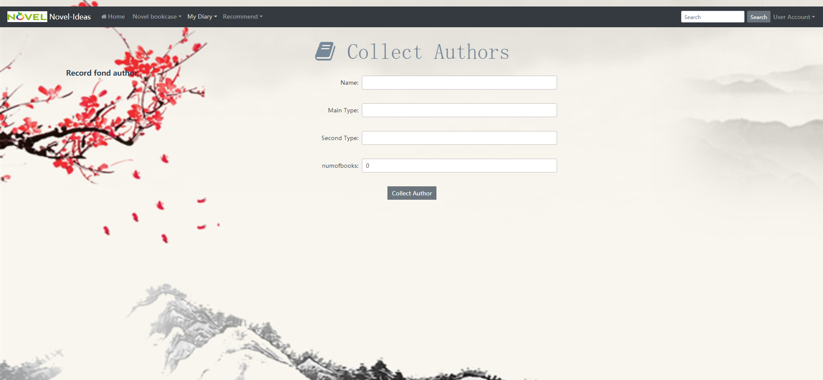

### Assets

Allow user to view the assets they collected

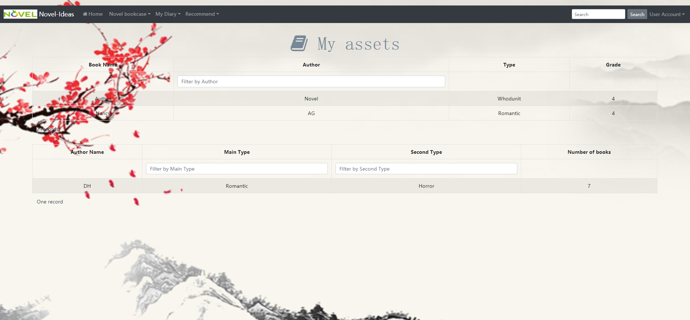

### Give grades

Click the give grade button in the novel page, user can give grade to the novel

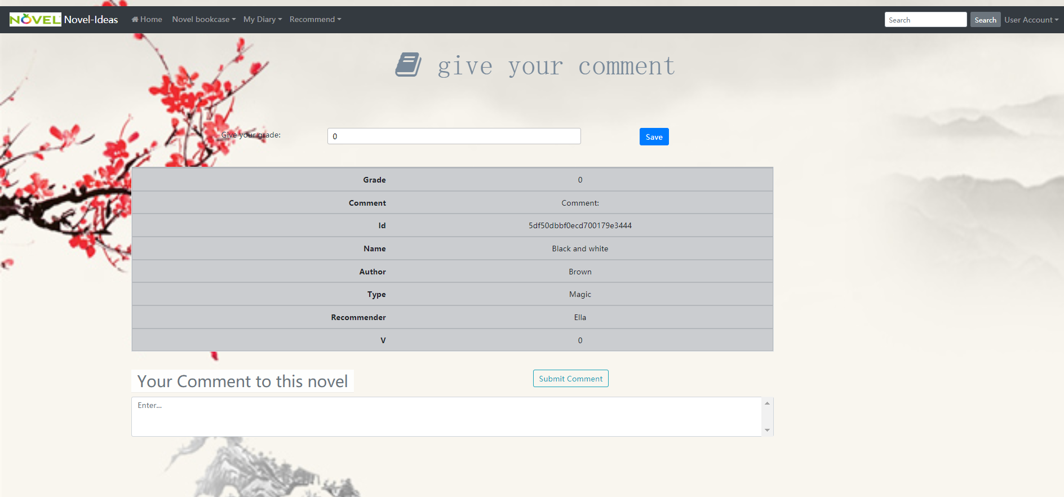

### Give comment

Click the Submit Comment user can share their comment to the novel

Delete

User can only delete the novel the recommend

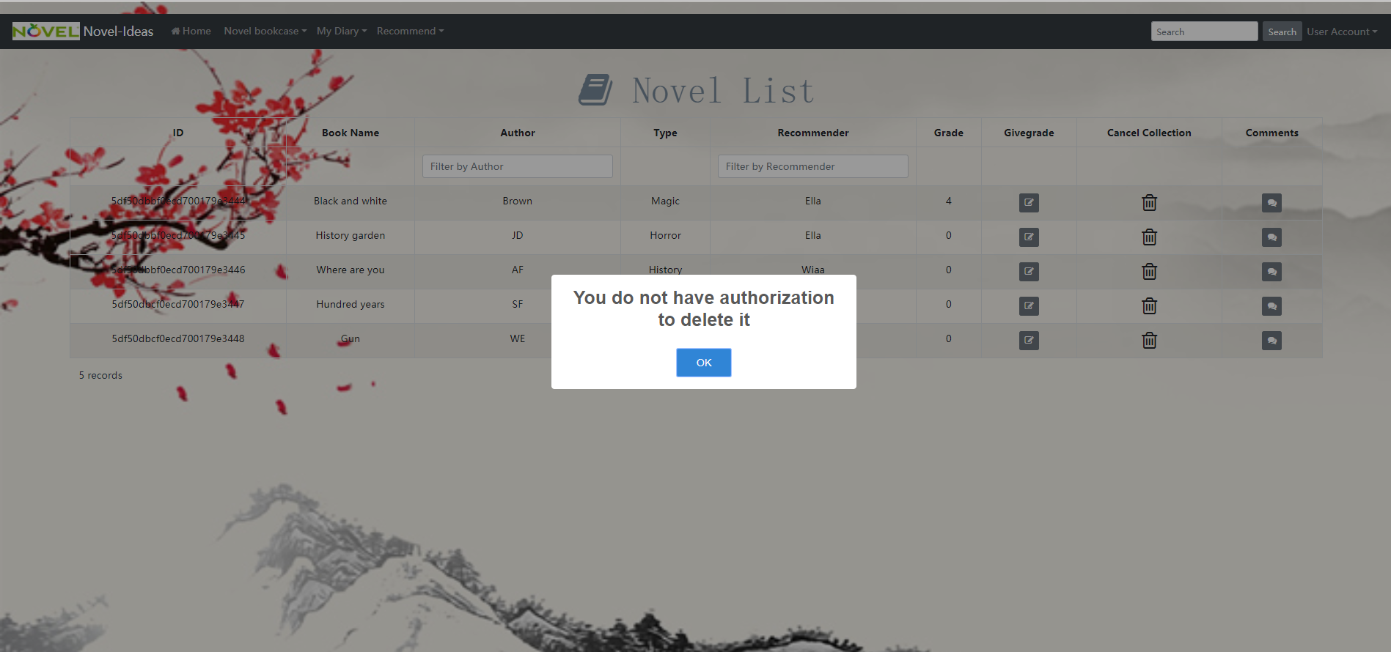

Have no authorization

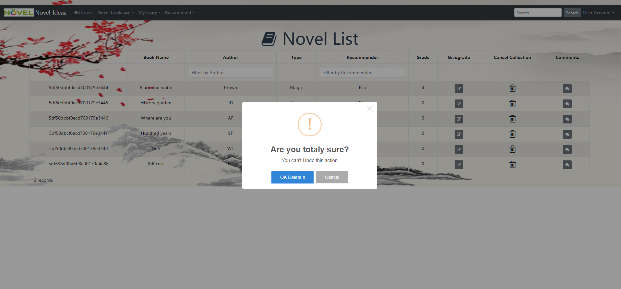

Have authorization

User can choose delete to delete the novel

Or user can cancel this action

### Comment

User can see the comment of the book

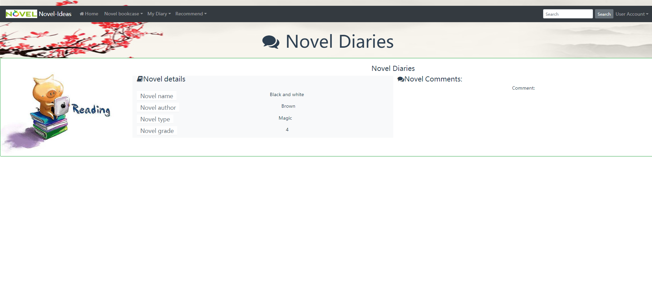

### User Info

User can see the information of themselves

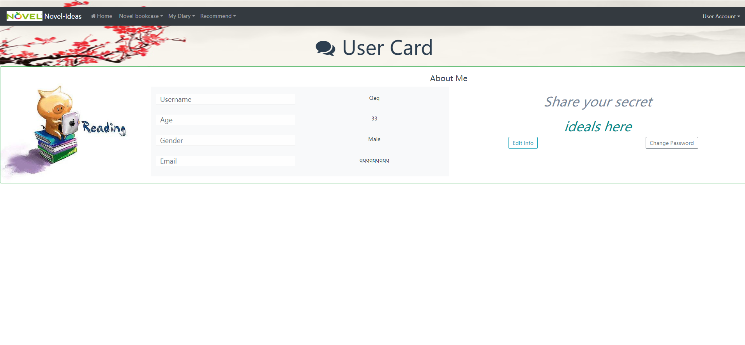

### Edit Info

User can change the information of themselves

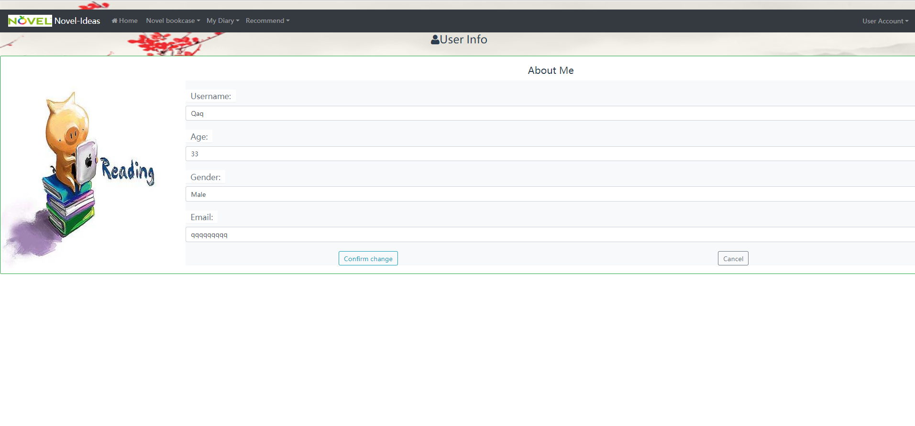

### Change Password

User can change the password by clicking the button change password

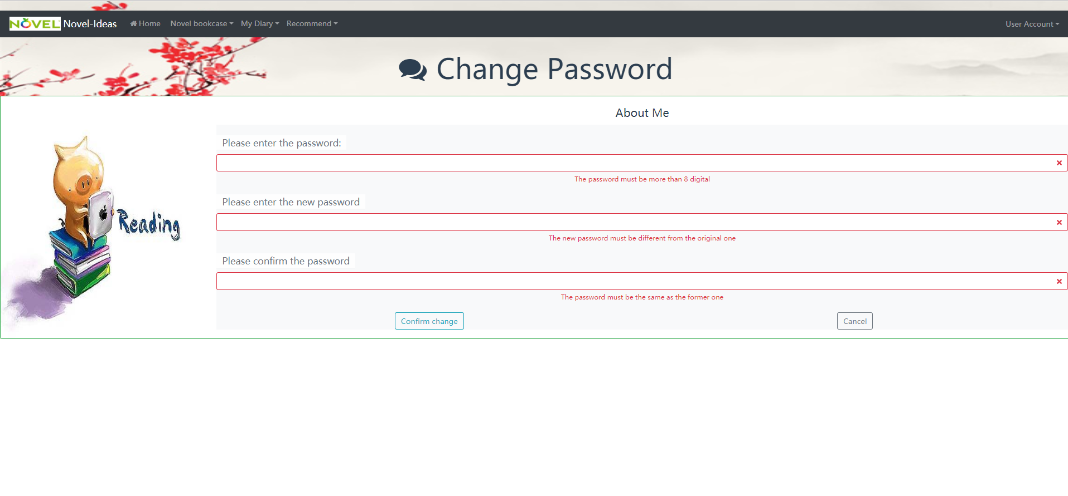

### Sign out

User can sign out

Delete the cookie

## Server:

<https://github.com/Ella-Xue/NovelIdeas-api>

<https://novelideas-api.herokuapp.com/>

user:

app.get('/user/:id', user.userInfo);  
app.post('/user',user.register);  
app.post('/user/login',user.login);  
app.put('/user/:id', user.editPassword);  
app.put('/user/:id/info',user.editInfo);  
app.put('/user/:id/novels',user.putNovel);  
app.put('/user/:id/authors',user.putAuthor);

a post for register

a post for login with username and password authentication

a get for user to see his own information

a put for user to change the password

a put to edit the information of the user

a put to collect novels

a put to collect authors

novels:

app.get('/novels', novels.findAll);  
app.get('/novels/:id', novels.findOne);  
app.post('/novels',novels.addNovel);  
app.put('/novels/:id', novels.giveGrade);  
app.put('/novels/:id/comment', novels.comment);  
app.delete('/novels/:id', novels.deleteNovel);

a get to get all novels information

a get to get a novel information

a post to add new novels

a put to give a grade to the novel

a put to add comment to the novel

a delete to delete the novel

author:

app.get('/author', author.findAll);  
app.get('/author/:id', author.findOne);  
app.post('/author', author.addAuthor);  
app.put('/author/:id/collect', author.collectAuthor);  
app.delete('/author/:id', author.removeCollection);

a get to get all author information

a get to get a author information

a post to recommend a new author

a put to collect the author, add 1 to the author’s number of collected

a delete to remove the author

## Frameworks used:

### Client:

Vue CLI

Vue-Router

BootstrapVue

Node

### Server:

MongoDB

Vue.js

Express

Node

## Automatic testing with cypress:

Client:

<https://gitlab.com/Ella12138/novelideas_front/tree/develop>

Recorded Run: <https://dashboard.cypress.io/projects/nwgogh/runs/9/specs>

Server:

<https://gitlab.com/Ella12138/novelideas>

Database schema

User: sample data

<https://gitlab.com/Ella12138/novelideas_front/blob/master/cypress/fixtures/user.json>

Novel: sample data

<https://gitlab.com/Ella12138/novelideas_front/blob/master/cypress/fixtures/author.json>

Author : sample data <https://gitlab.com/Ella12138/novelideas_front/blob/master/cypress/fixtures/author.json>

UML: use case diagram

